

**FACULTY OF ENGINEERING & TECHNOLOGY**

**DEPARTMENT OF ELECTRICAL AND COMPUTER ENGINEERING**

**Computer Networks Laboratory - ENCS4130**

**Experiment. 10 Report**

**Cisco ASA Firewall Configuration**

**Prepared by:** Layan Salem 1221026

**Instructor: Dr.** Sameh Awad

**T.A:** **Eng.** Tariq Odeh

**Section:** 3

**Date:** 25-May-2025

**Place:** Computer Network Lab

# Abstract

In this experiment, the Cisco Adaptive Security Appliance (ASA) firewall was configured to secure a simulated network environment. The primary objectives were to set up security zones with appropriate security levels, implement Network Address Translation (NAT) through both static NAT and Port Address Translation (PAT), create and apply Access Control Lists (ACLs) to control traffic between different network zones, and configure a wireless access point to provide secure wireless connectivity for internal devices. The ASA was also configured as a DHCP server to dynamically assign IP addresses within the internal network. Testing was performed to validate DNS resolution, HTTP access, and ICMP behavior across the internal, DMZ, and external zones. It was expected that secure communication would be established, while necessary services such as web and DNS servers remained accessible. The expected outcomes were successfully achieved, with the firewall effectively managing and controlling network traffic.

# Table of Content

1 Abstract II

2 Table of Content III

3 Table of Figures V

4 Table of tables VI

5 Introduction 1

5.1 Cisco Adaptive Security Appliance (ASA) 1

5.1.1 Demilitarized Zone (DMZ) 2

5.1.2 Network Address Translation (NAT) 2

5.1.3 Configuration of Cisco ASA Firewall 3

6 Procedure and Discussion 6

6.1 Topology 6

6.2 Network Setup and Configuration 6

6.2.1 Configuring Static IPs for Routers Interfaces 6

6.2.2 Configuring OSPF and BGP Routing Protocols 7

6.3 Servers Configuration 8

6.3.1 Birzeit Web Server (www.birzeit.edu) 8

6.3.2 Birzeit DNS Server (dns.birzeit.edu) 9

6.3.3 Amazon Web Server (www.amazon.com) 10

6.3.4 Amazon DNS Server (dns.amazon.com) 11

6.4 ASA Firewall Configuration 12

6.4.1 Configuring Privileged Mode Password 12

6.4.2 Configuring Interfaces and Security Zones 12

6.4.3 Configuring PAT for the Internal Network 13

6.4.4 Configuring Static NAT for the DMZ Network 13

6.4.5 Enabling External Access to DMZ Servers 14

6.4.6 Enabling Return Traffic for HTTP, DNS, and ICMP to the Internal LAN 14

6.4.7 Configuring Default Routing 15

6.4.8 Configuring ASA as a DHCP Server for the Internal LAN 15

6.5 Access Point Configuration 17

6.6 Connecting Wireless Devices and Configuring Dynamic IP Addresses 17

6.7 Configuring End Devices with Static IP Addresses 19

7 Testing and Verification 20

7.1 Accessing “www.birzeit.edu” from PC Amazon (Internet) 20

7.2 Accessing “www.amazon.com” from Smartphone (Birzeit Internal Network) 21

7.3 Pinging a Host in Birzeit Network from PC Amazon (Internet) 21

7.4 Pinging PC Amazon (Internet) from a Host in Birzeit Network 22

8 Conclusion 23

9 Feedback 24

10 References 25

# Table of Figures

Figure 1 firewall [1] 1

Figure 2 DMZ[4] 2

Figure 3 NAT 3

Figure 4 topology 6

Figure 5 static IP for router0 6

Figure 6 Configuration of Web Services on www.birzeit.edu 8

Figure 7 IP Configuration of Birzeit Web Server. 8

Figure 8 DNS Records Configuration on dns.birzeit.edu 9

Figure 9 IP Configuration of Birzeit DNS Server 9

Figure 10 Configuration of Web Services on www.amazon.com. 10

Figure 11 IP Configuration of Amazon Web Server. 10

Figure 12 DNS Records on dns.amazon.com. 11

Figure 13 IP Configuration of Amazon DNS Server. 11

Figure 14 ASA Privileged Mode Password Configuration. 12

Figure 15 ASA Interface and Zone Configuration. 12

Figure 16 Static NAT Configuration for DMZ Servers. 13

Figure 17 ACL Rules Allowing Access to DMZ Servers. 14

Figure 18 Protocol Inspection Configuration on ASA. 14

Figure 19 DHCP Lease Information for laptop 15

Figure 20 DHCP Lease Information for tablet 16

Figure 21 DHCP Lease Information for phone 16

Figure 22 Wireless Access Point Configuration (SSID and WPA2 Setup). 17

Figure 23 tablet Wireless Configuration and DHCP Assignment. 17

Figure 24 Laptop Wireless Configuration. 18

Figure 25 phone Wireless Configuration. 18

Figure 26 Static IP Configuration of Internal Printer. 19

Figure 27 Static IP Configuration of Amazon Network PC. 19

Figure 28 Web browser accessing www.birzeit.edu from PC Amazon. 20

Figure 29 Ping test from PC Amazon to www.birzeit.edu showing successful response. 20

Figure 30 Web browser on the smartphone accessing www.amazon.com 21

Figure 31 Failed ping from PC Amazon to internal Birzeit PC. 21

Figure 32 ping from Birzeit tablet to PC Amazon. 22

# Table of tables

Table 1 routers Ips 7

# Introduction

A firewall is a network security system that monitors and controls network traffic based on established security rules. It acts as a barrier between a secure internal network and an untrusted external network such as the Internet. Firewalls are essential for protecting systems against unauthorized access, malware, and cyberattacks. They operate by inspecting incoming and outgoing traffic and determining whether to allow it based on predefined policies. There are different types of firewalls including packet-filtering, stateful inspection, proxy, and next-generation firewalls, each offering varying levels of protection and control.[1]

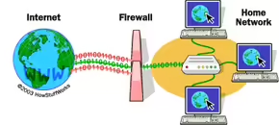

Figure 1 firewall [1]

## Cisco Adaptive Security Appliance (ASA)

The Cisco Adaptive Security Appliance (ASA) is an integrated security solution that functions as a firewall while also offering capabilities such as intrusion prevention, antivirus filtering, and virtual private networking (VPN). ASA is designed to provide proactive threat defense by inspecting traffic and stopping attacks before they spread within the network. This makes it suitable for both small-scale and enterprise-level network environment [2].

Cisco ASA is the successor to the PIX firewall series and brings a comprehensive package of features into a single platform. It can be deployed as a perimeter firewall, VPN concentrator, or access control point between network zones such as internal LANs and public or semi-public zones like the DMZ. By default, Cisco ASA applies a security level system that prioritizes internal network safety by denying uninitiated inbound traffic from less trusted networks [3].

### Demilitarized Zone (DMZ)

A Demilitarized Zone (DMZ) is a specialized subnet positioned between a secure internal network and an untrusted external network such as the Internet. It provides controlled access to services that need to be publicly accessible such as web servers, DNS servers, and FTP servers while isolating them from the internal network to limit the blast radius in case of a compromise [4].

The Cisco ASA enables DMZ implementation by assigning an intermediate security level (commonly 50) to a specific interface. This interface hosts public-facing services and is isolated from both the most trusted internal network (inside, level 100) and the least trusted external network (outside, level 0). In many enterprise architectures, the DMZ sits between two firewalls or interfaces an external-facing one that restricts public access and an internal one that guards internal resources. This configuration ensures layered defense, making it harder for attackers to pivot into the private network even if a DMZ server is compromised [3].

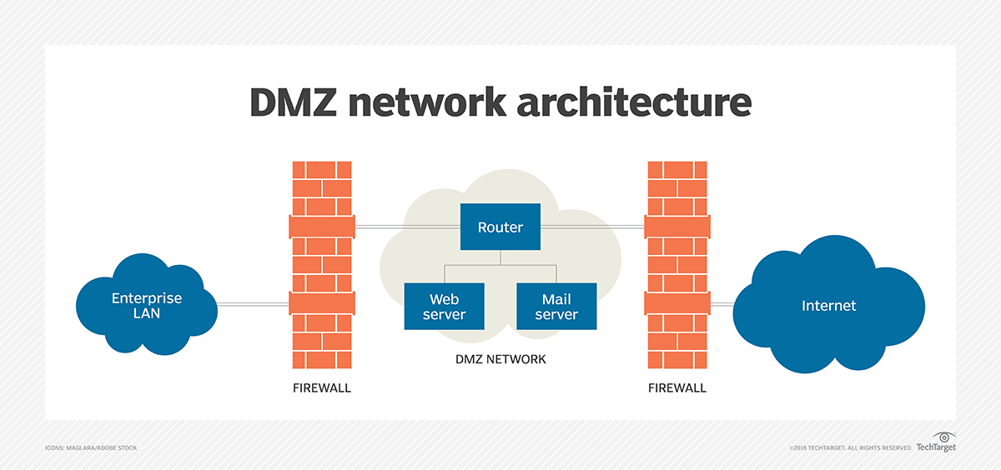

Figure 2 DMZ[4]

### Network Address Translation (NAT)

Network Address Translation (NAT) is a method used in IP networking to allow multiple devices within a private network to access external networks using a limited number of public IP addresses. NAT functions by translating private IP addresses into public IPs before packets are forwarded to the Internet. This process not only conserves public address space but also adds a layer of privacy by hiding internal network structure [5].

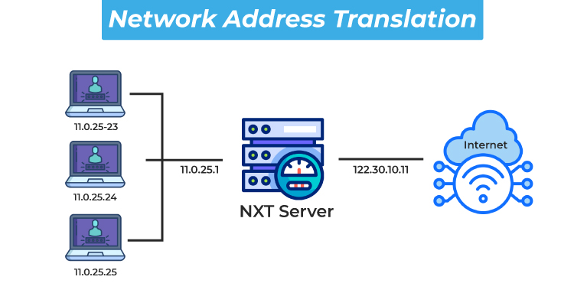

Figure 3 NAT

Cisco ASA supports several types of NAT:

* **Static NAT** provides a fixed one-to-one mapping, often used for DMZ servers that must always be reachable via the same public IP.
* **Dynamic NAT** maps internal addresses to a pool of public IPs as needed.
* **Port Address Translation (PAT)** allows multiple devices to share a single public IP using unique port numbers, making it the most efficient NAT type.

Although NAT is not primarily a security feature, it offers indirect protection by obscuring internal hosts from direct exposure to external networks. In combination with access control lists (ACLs), it helps reduce the attack surface. Cisco ASA implements NAT rules as part of its security policies, controlling how internal, DMZ, and external traffic is translated and routed [3].

### Configuration of Cisco ASA Firewall

Configuring a Cisco ASA firewall involves several structured steps to ensure that security zones, traffic control, address translation, and routing are all properly managed. The ASA’s configuration model follows a zone-based architecture, using security levels, access control policies, and inspection mechanisms to regulate data flow across network segments such as the internal LAN, DMZ, and Internet-facing interfaces.

#### **Configure Interfaces and Security Zones**

In Cisco ASA, each interface must be configured with a name, IP address, and **security level**, which defines its trustworthiness. The security levels range from 0 (least trusted) to 100 (most trusted). Typical assignments are:

* Inside: 100 (trusted internal network)
* DMZ: 50 (semi-trusted public-facing servers)
* Outside: 0 (untrusted external network)

This tiered trust model simplifies traffic flow: by default, traffic is allowed to flow from higher to lower security levels but not vice versa. Administrators can define exceptions through Access Control Lists (ACLs) and inspection rules [3].

#### **Configure Port Address Translation (PAT)**

**PAT**, also known as **NAT Overload**, allows multiple internal devices to share a single public IP address by assigning each session a unique port number. This method is highly efficient for conserving IP addresses and is commonly used in enterprise settings for outbound Internet access.

PAT is implemented by defining network objects and dynamically mapping internal subnets to the firewall’s public interface. This setup not only provides scalability but also obscures internal IPs from the public, enhancing security through address masking [6].

#### **Configure Static NAT**

**Static NAT** is used for one-to-one translation between internal private IPs and publicly routable IP addresses. This configuration is essential for making services like web or DNS servers in the DMZ reachable from external networks.

By ensuring consistent address mapping, static NAT enables reliable access to critical resources while maintaining the isolation and control benefits of a firewall. It is typically applied to hosts in the DMZ that require predictable public IPs for inbound traffic [7].

#### **Enable Legitimate Traffic Flow from Lower to Higher Security Levels**

Cisco ASA firewalls **block traffic from lower to higher security levels** by default (e.g., from outside to inside). To permit legitimate traffic such as HTTP requests to a DMZ server, **Access Control Lists (ACLs)** must be configured to explicitly allow specific protocols and source/destination pairs.

Additionally, ASA uses **stateful packet inspection**, meaning it tracks active sessions and allows return traffic for permitted connections. This ensures bidirectional communication while maintaining strict inbound control. Protocol inspection (e.g., HTTP, DNS) must be explicitly enabled for application-layer traffic to return properly to the initiating client

#### **Configure Static Route**

To ensure that outbound traffic reaches external destinations, the ASA must be configured with a **static route**, typically a default route that forwards packets to the next-hop gateway (usually an upstream router).

This is a fundamental part of routing logic and ensures Internet-bound traffic from internal and DMZ zones is correctly relayed out of the firewall. Static routing is essential when dynamic routing protocols are not used or necessary for the deployment [3].

#### **Configure DHCP**

Cisco ASA can function as a **DHCP server** for internal devices, dynamically allocating IP addresses and network configuration (such as DNS and gateway). This service simplifies device management by eliminating the need for manual IP setup.

DHCP can be restricted to specific interfaces (e.g., “inside”), and the IP pool can be adjusted to reserve static addresses for printers or other critical devices. ASA also allows assigning DNS server information through DHCP options, ensuring integrated name resolution in the network [3].

# Procedure and Discussion

## Topology

The topology after built in Cisco packet tracer, see fig 5.

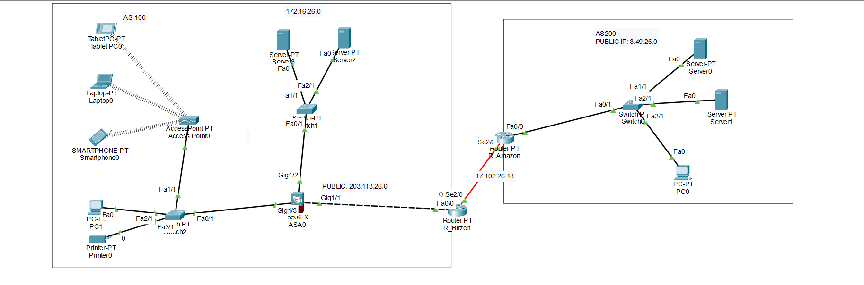

Figure 4 topology

## Network Setup and Configuration

### Configuring Static IPs for Routers Interfaces

First, I assigned static IP addresses to the router interfaces as shown in Figure 6:

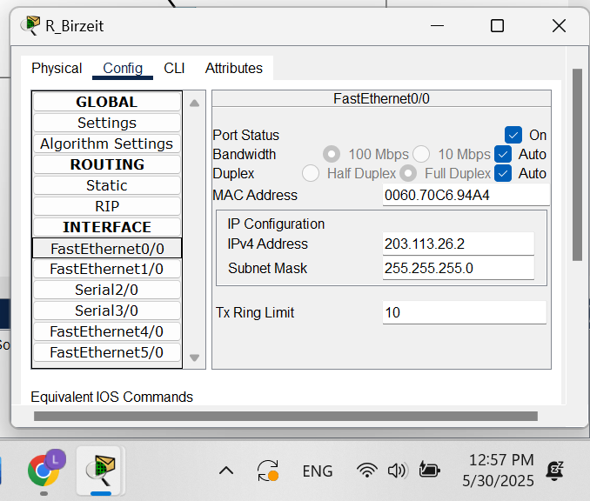

Figure 5 static IP for router0

The table below summarizes each router interface along with its assigned IP address.

Table 1 routers Ips

|  |  |  |  |  |
| --- | --- | --- | --- | --- |
| **Device** | **Interface** | **Network IP address** | **Subnet Mask** | **Link** |
| R_Birzeit | Fa0/0 | 203.113.26.2 | 255.255.255.0 | ASA (Outside) |
| R_Birzeit | Se2/0 | 17.102.26.49 | 255.255.255.252 | R_Amazon |
| R_Amazon | Fa0/0 | 17.102.26.50 | 255.255.255.252 | |  | | --- | |  |  |  | | --- | | R_Birzeit | |
| R_Amazon | Se2/0 | 172.31.26.2 | 255.255.255.0 | Amazon PC |

### Configuring OSPF and BGP Routing Protocols

To enable routing within and between networks, OSPF was configured for intra-domain routing, while BGP was used for inter-domain routing between R_Birzeit and R_Amazon.

1. on R_Birzeit, i use the following commands:

* router ospf 1
* log-adjacency-changes
* redistribute bgp 100 subnets
* network 203.113.26.0 0.0.0.255 area 0
* router bgp 100
* bgp log-neighbor-changes
* no synchronization
* neighbor 17.102.26.50 remote-as 200
* redistribute ospf 1

1. on R_Amazon, i use the following commands:

* router ospf 1
* log-adjacency-changes
* redistribute bgp 200 subnets
* network 203.113.26.0 0.0.0.255 area 0
* router bgp 200
* bgp log-neighbor-changes
* no synchronization
* neighbor 17.102.26.49 remote-as 100
* redistribute ospf 1

## Servers Configuration

### Birzeit Web Server (www.birzeit.edu)

This server was placed in the DMZ and configured to support HTTP and HTTPS services. It was assigned a private IP and mapped to a public IP using static NAT on the ASA.

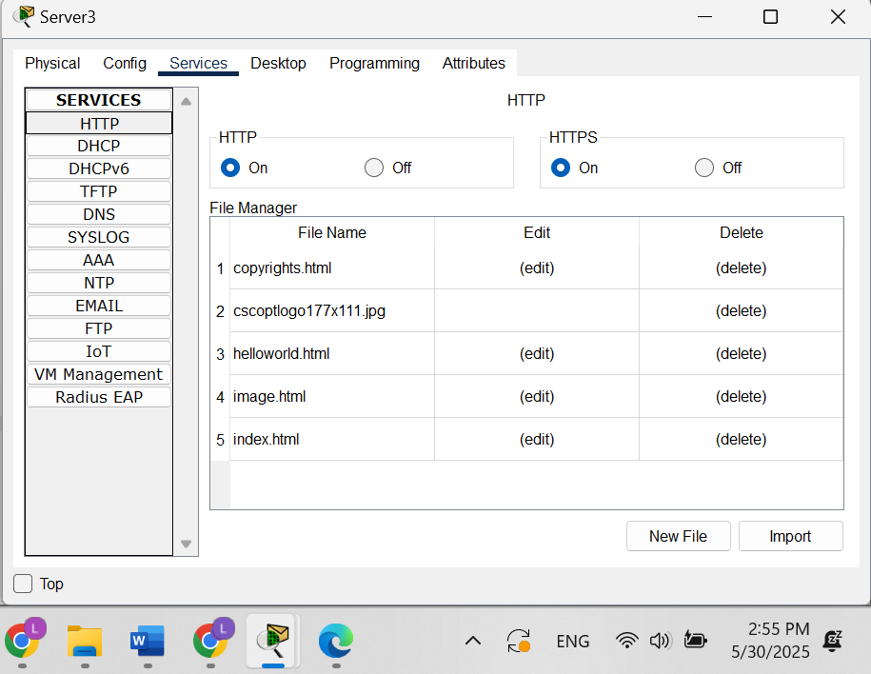

Figure 6 Configuration of Web Services on [www.birzeit.edu](http://www.birzeit.edu)

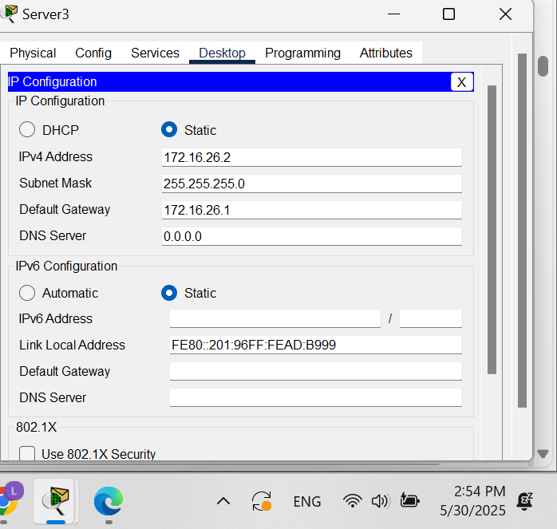

Figure 7 IP Configuration of Birzeit Web Server.

### Birzeit DNS Server (dns.birzeit.edu)

The DNS server in Birzeit was configured to resolve local domain names. DNS records were added to support resolution for all critical devices in the network.

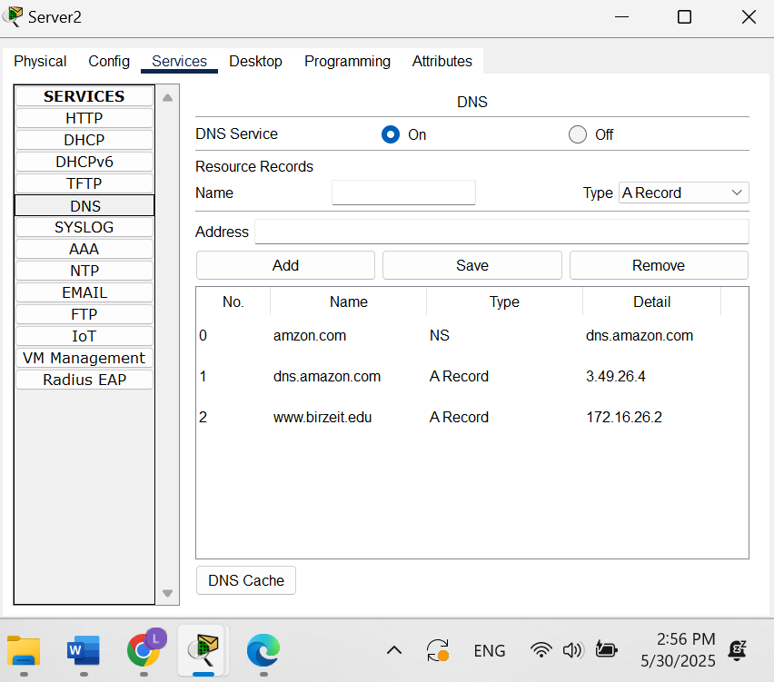

Figure 8 DNS Records Configuration on dns.birzeit.edu

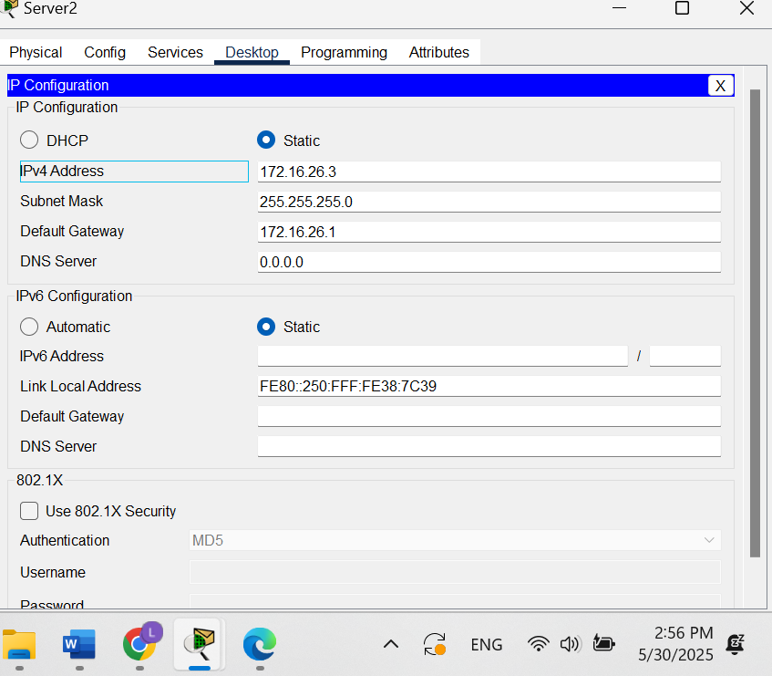

Figure 9 IP Configuration of Birzeit DNS Server

### Amazon Web Server (www.amazon.com)

This web server was placed in the Amazon internal LAN. It was configured with a static IP and HTTP service was enabled.

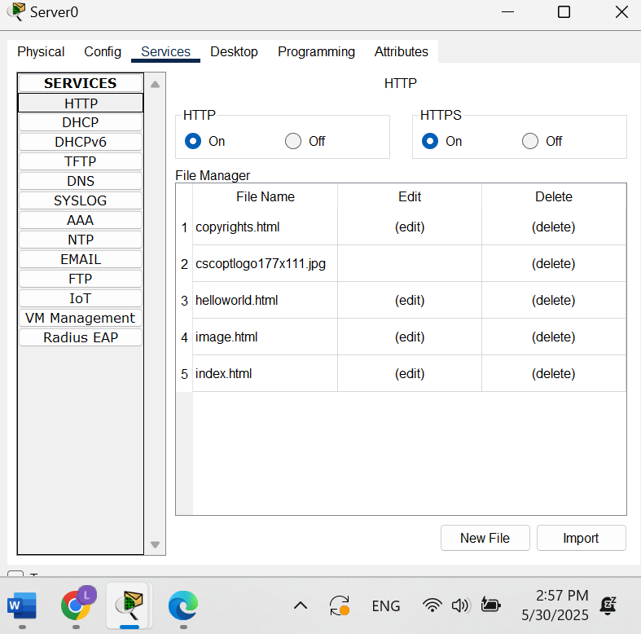

Figure 10 Configuration of Web Services on [www.amazon.com](http://www.amazon.com).

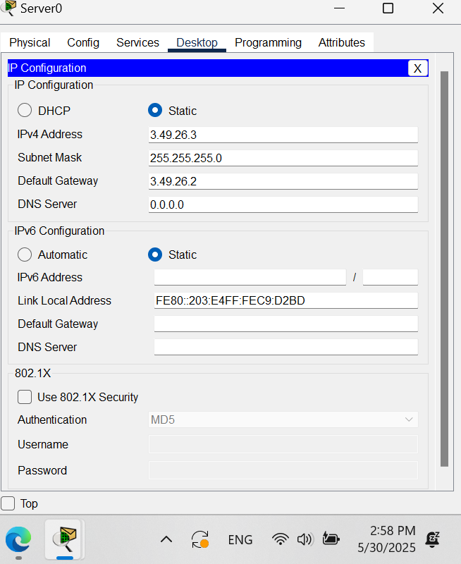

Figure 11 IP Configuration of Amazon Web Server.

### Amazon DNS Server (dns.amazon.com)

The DNS server for the Amazon network was configured with static IP settings and DNS entries for internal devices.

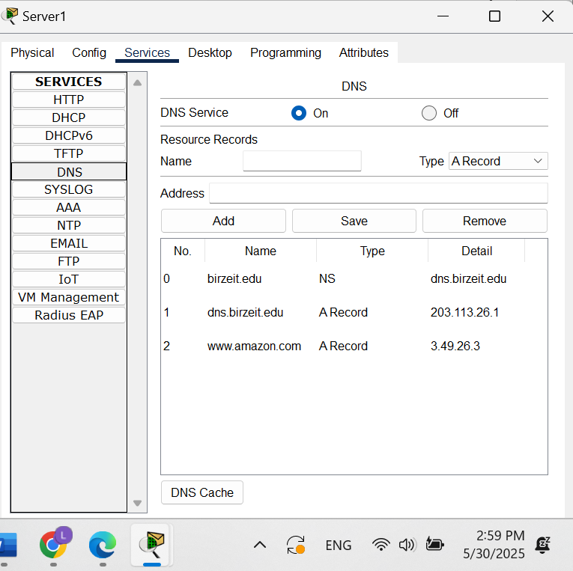

Figure 12 DNS Records on dns.amazon.com.

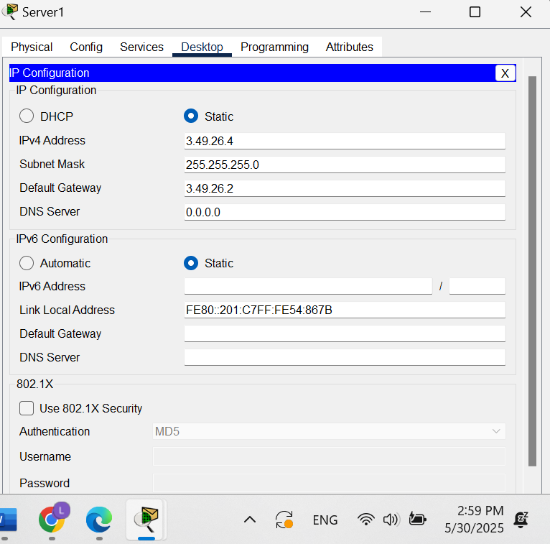

Figure 13 IP Configuration of Amazon DNS Server.

Configuring the web and DNS servers validated how services are made publicly accessible (via DMZ and NAT) or remain private (within the LAN). These servers simulated real-world infrastructure for hosting and resolving domain names, which were later tested from different network zones.

## ASA Firewall Configuration

### Configuring Privileged Mode Password

A password was set for privileged EXEC mode to secure administrative access to the ASA firewall.

* enable
* configure terminal
* enable password encs4130

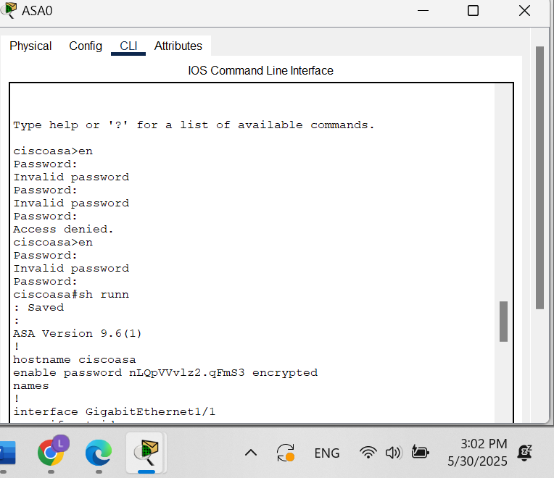

Figure 14 ASA Privileged Mode Password Configuration.

### Configuring Interfaces and Security Zones

Three ASA interfaces were configured and assigned appropriate names and security levels:

* Inside (100), DMZ (50) , Outside (0)

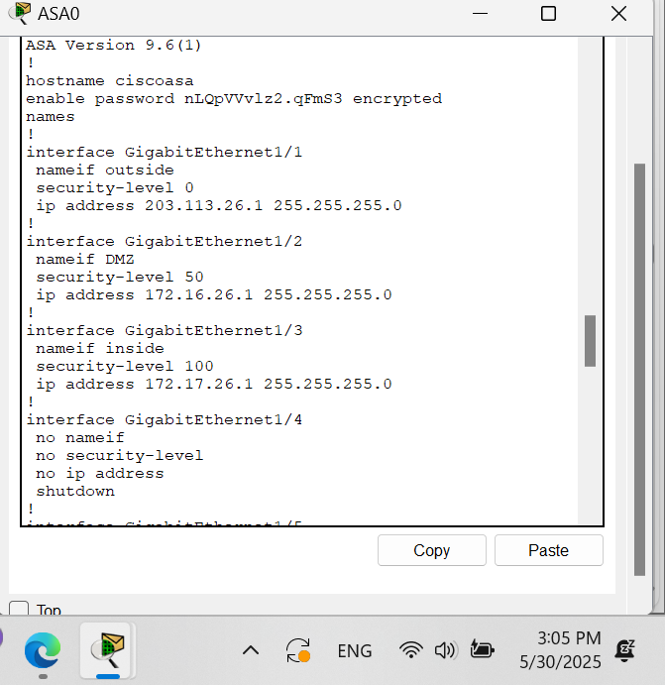

Figure 15 ASA Interface and Zone Configuration.

### Configuring PAT for the Internal Network

PAT was set up for inside users to access the outside world using a single public IP on the ASA outside interface.

Commands:

* object network INTERNAL-PAT
* subnet 172.17.26.0 255.255.255.0
* nat (inside,outside) dynamic interface

### Configuring Static NAT for the DMZ Network

Static NAT was applied for DMZ servers so they could be accessed from the public network via their public IP addresses.

* object network DMZ-WEB-NAT
* host 172.16.26.2
* nat (DMZ,outside) static 203.113.26.3
* object network DMZ-dns-NAT
* host 172.16.26.3
* nat (DMZ,outside) static 203.113.26.3
* object network INTERNAL-PAT
* subnet 172.17.26.0 255.255.255.0
* nat (inside,outside) dynamic interface

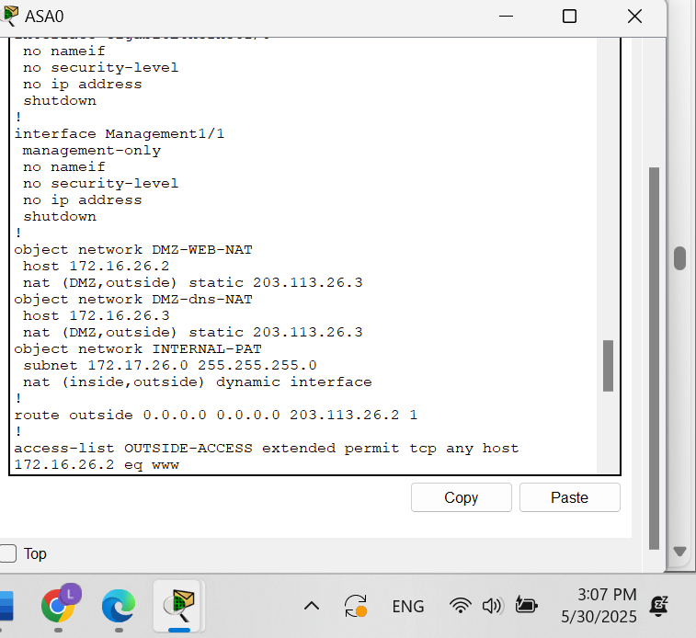

Figure 16 Static NAT Configuration for DMZ Servers.

### Enabling External Access to DMZ Servers

Access Control Lists (ACLs) were applied to the outside interface to allow inbound HTTP and DNS requests to reach the DMZ servers.

Commands:

* access-list OUTSIDE-ACCESS extended permit tcp any host 172.16.26.2 eq www
* access-list OUTSIDE-ACCESS extended permit udp any host 172.16.26.3 eq domain
* access-group OUTSIDE-ACCESS in interface outside

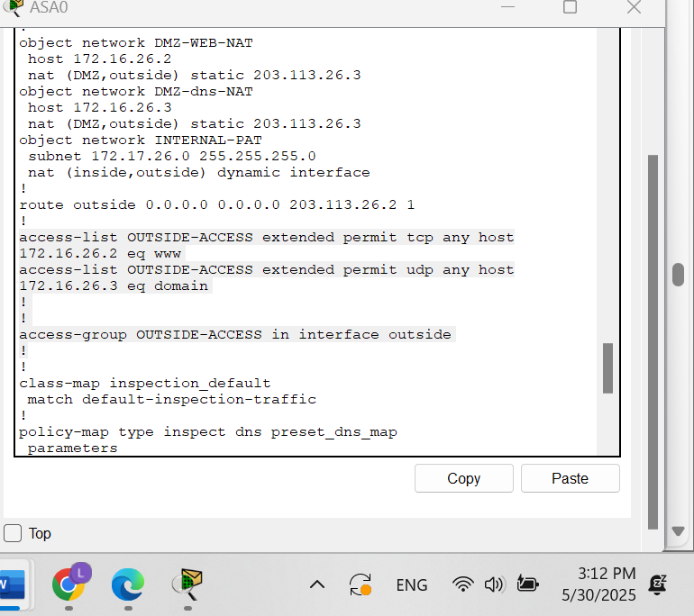

Figure 17 ACL Rules Allowing Access to DMZ Servers.

### Enabling Return Traffic for HTTP, DNS, and ICMP to the Internal LAN

Protocol inspection was enabled for HTTP, DNS, and ICMP to allow return traffic for internal users communicating with external services.

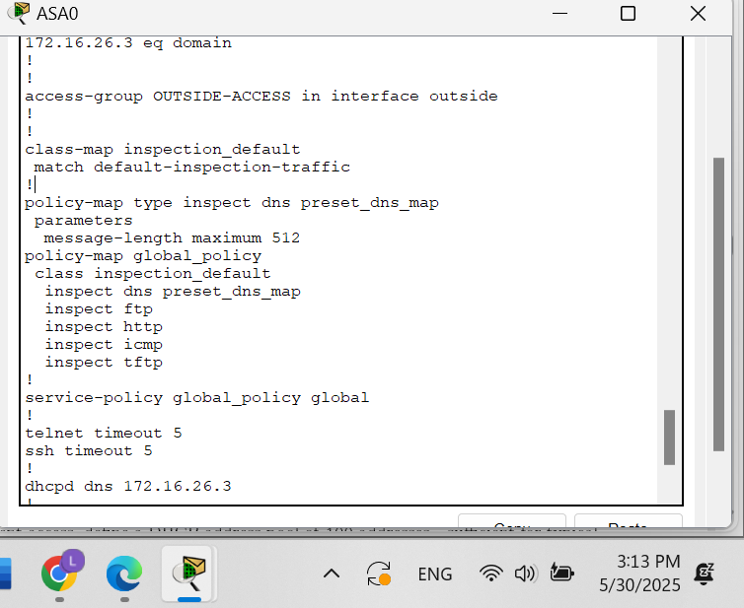

Figure 18 Protocol Inspection Configuration on ASA.

### Configuring Default Routing

A default static route was added on the ASA to route all unknown traffic to the next-hop IP on the outside network.

* route outside 0.0.0.0 0.0.0.0 203.113.26.2 1

### Configuring ASA as a DHCP Server for the Internal LAN

The ASA was configured to provide DHCP services on the inside interface. A pool was defined to allocate IP addresses to internal clients.

DHCP Server Configuration on ASA:

* dhcpd dns 172.16.26.3
* dhcpd address 172.17.26.3-172.17.26.102 inside
* dhcpd enable inside

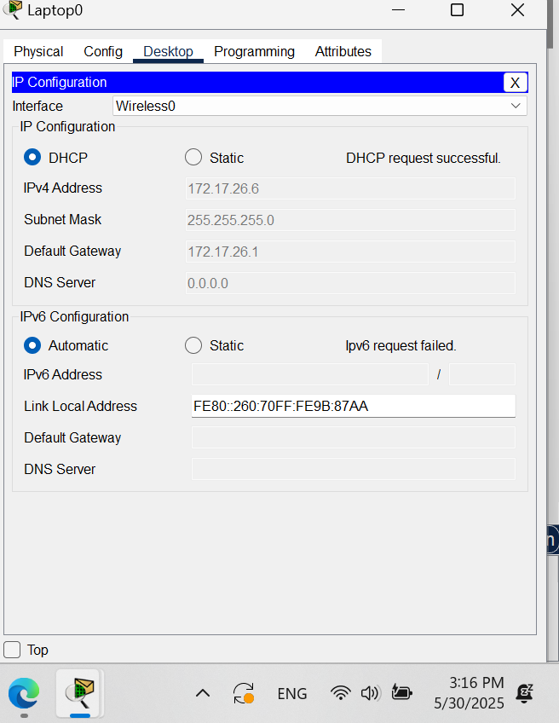

Figure 19 DHCP Lease Information for laptop

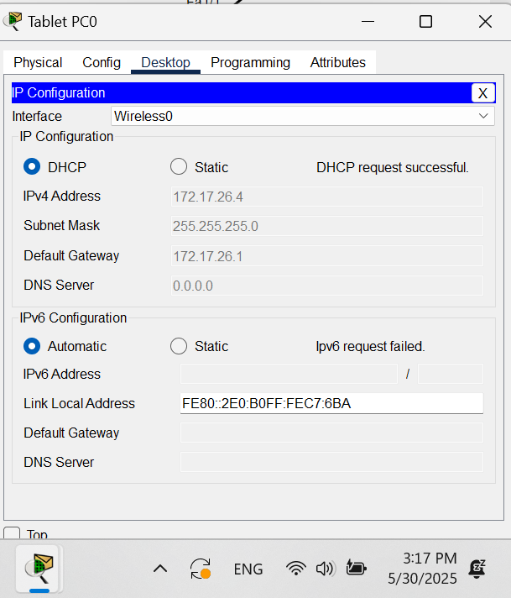

Figure 20 DHCP Lease Information for tablet

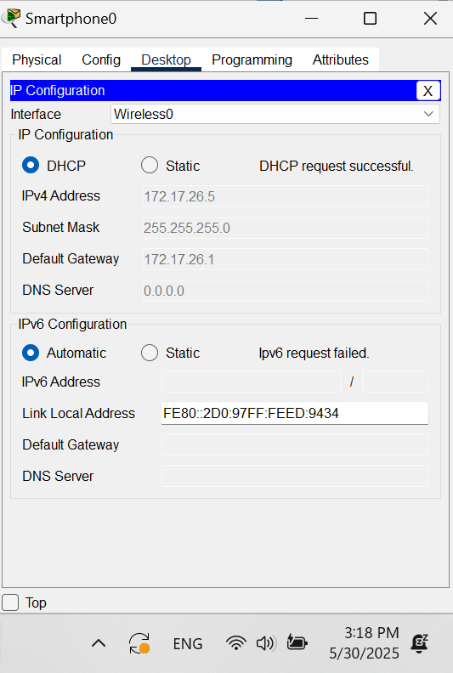

Figure 21 DHCP Lease Information for phone

This section highlighted the ASA's versatility. Security zones were used to enforce trust boundaries, PAT enabled inside users to access the Internet, and static NAT exposed DMZ servers safely. ACLs ensured granular access control, while DHCP simplified IP assignment for internal clients.

## Access Point Configuration

An access point was added to the internal LAN to support wireless connectivity. WPA2 encryption and a secure pre-shared key were used.

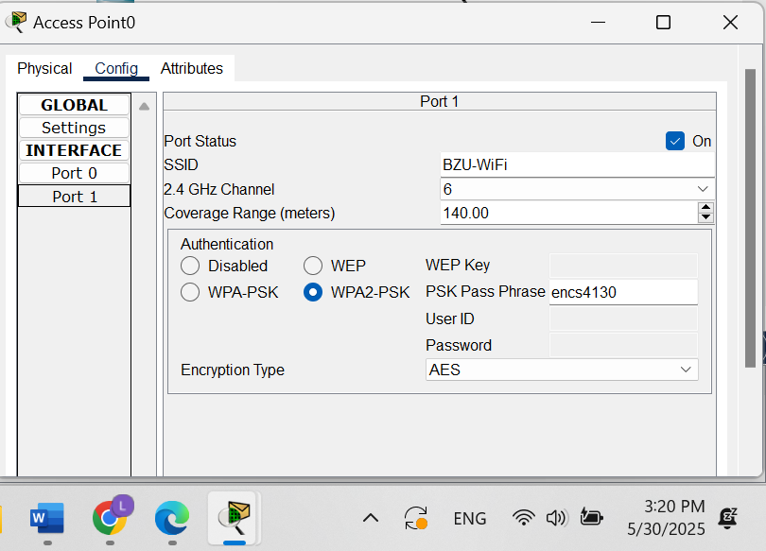

Figure 22 Wireless Access Point Configuration (SSID and WPA2 Setup).

Adding a wireless access point showcased secure Wi-Fi deployment. Enabling WPA2 encryption and DHCP for wireless clients simulated a realistic BYOD scenario in enterprise networks.

## Connecting Wireless Devices and Configuring Dynamic IP Addresses

A laptop was connected to the wireless network and set to obtain its IP address dynamically. It successfully received IP configuration from the ASA’s DHCP service.

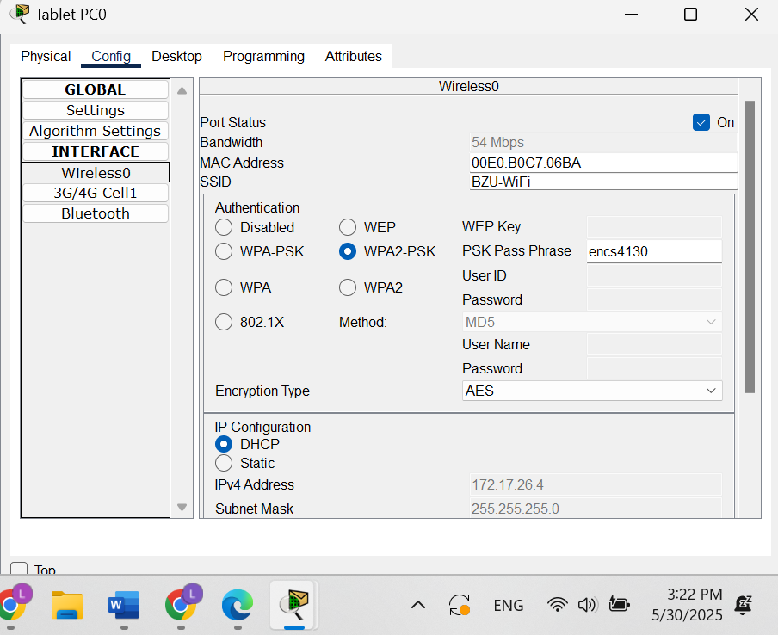

Figure 23 tablet Wireless Configuration and DHCP Assignment.

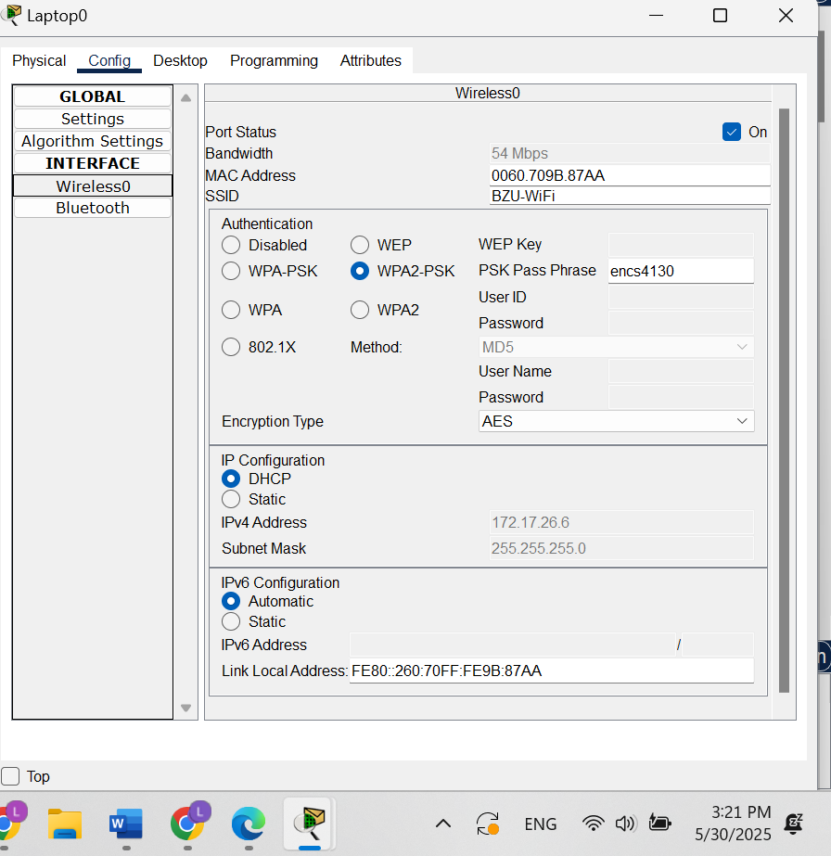

Figure 24 Laptop Wireless Configuration.

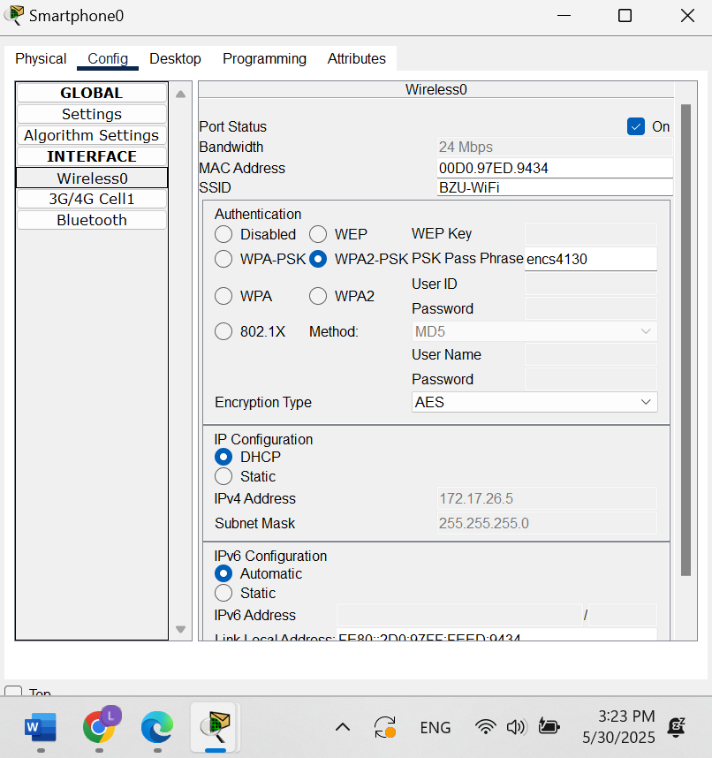

Figure 25 phone Wireless Configuration.

The successful dynamic configuration of the laptop verified that ASA’s DHCP server could assign proper addressing parameters. It also confirmed wireless integration with security and routing policies in place.

## Configuring End Devices with Static IP Addresses

Some end devices, such as the internal printer and the PC in the Amazon network, were assigned static IP addresses for consistent communication.

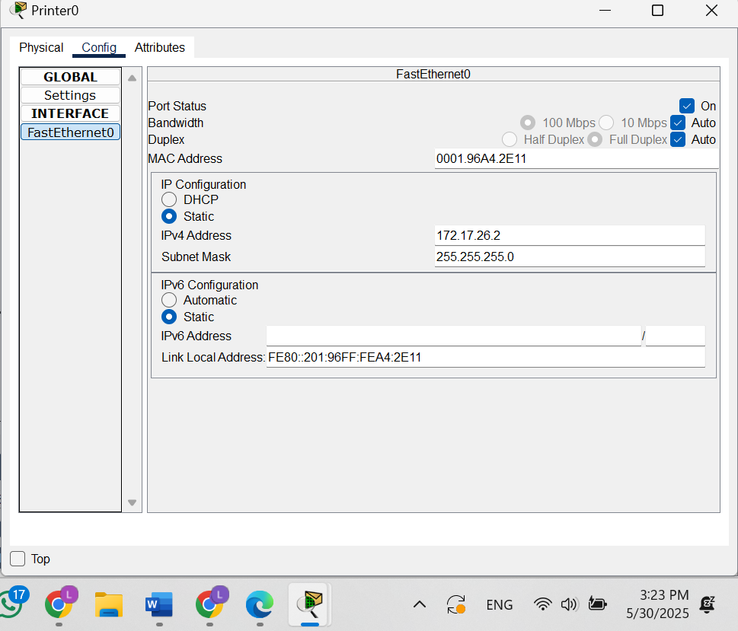

Figure 26 Static IP Configuration of Internal Printer.

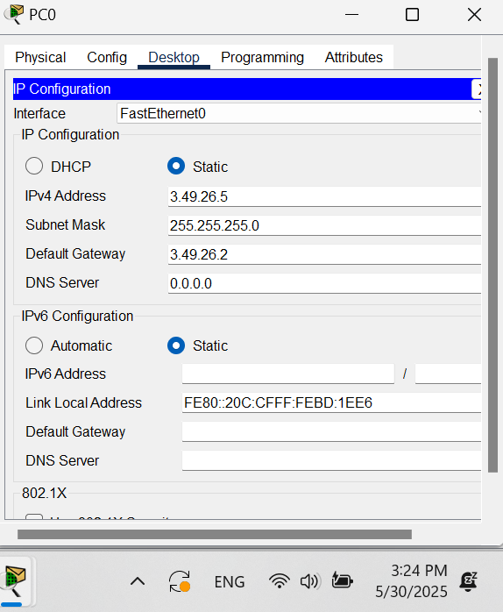

Figure 27 Static IP Configuration of Amazon Network PC.

Manually assigning static IPs to the printer and Amazon PC ensured consistent addressing for services that required reliability, like printing and internal file access. It also allowed mixed environments of static and dynamic addressing.

# Testing and Verification

## Accessing “www.birzeit.edu” from PC Amazon (Internet)

To verify static NAT and ACL configurations, we attempted to access the Birzeit web server (www.birzeit.edu) from PC Amazon, which resides in the external (Internet) zone. The server's public IP address was entered into a browser, and DNS resolution was tested using ping.

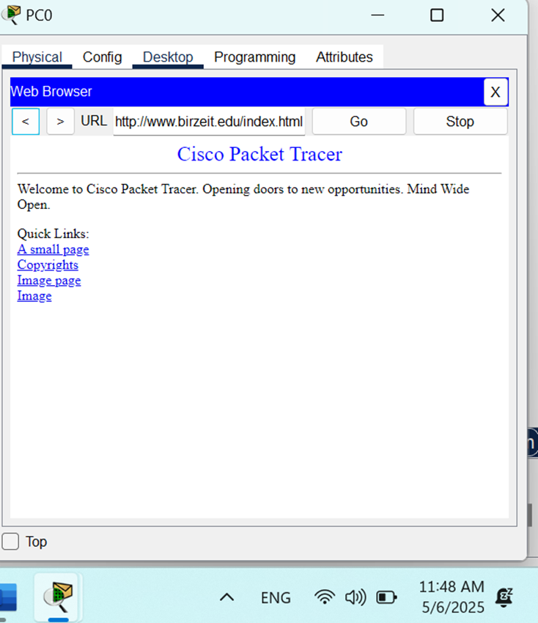

Figure 28 Web browser accessing www.birzeit.edu from PC Amazon.

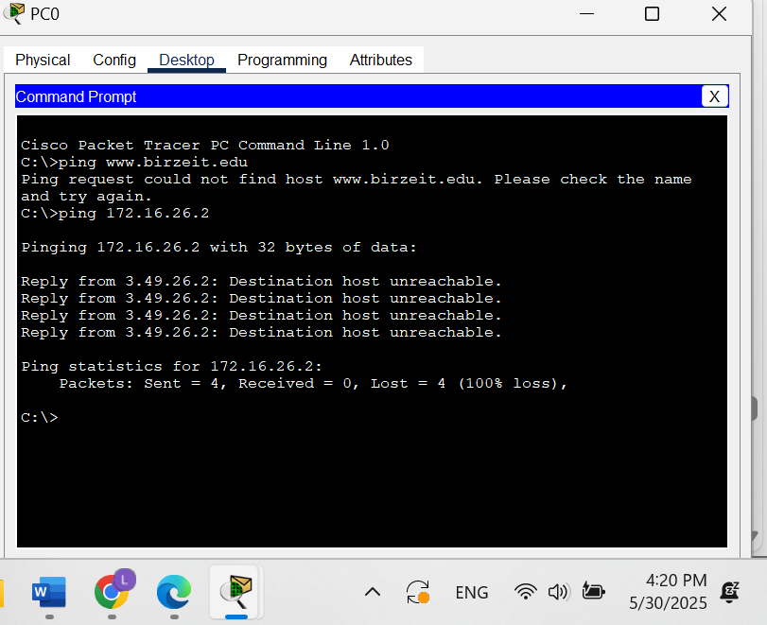

Figure 29 Ping test from PC Amazon to www.birzeit.edu showing successful response.

## Accessing “www.amazon.com” from Smartphone (Birzeit Internal Network)

This test checks if PAT and DNS forwarding are working correctly from the inside network. The wireless smartphone, connected to the BZU-WiFi access point, was used to access the Amazon web server located in the Amazon LAN.

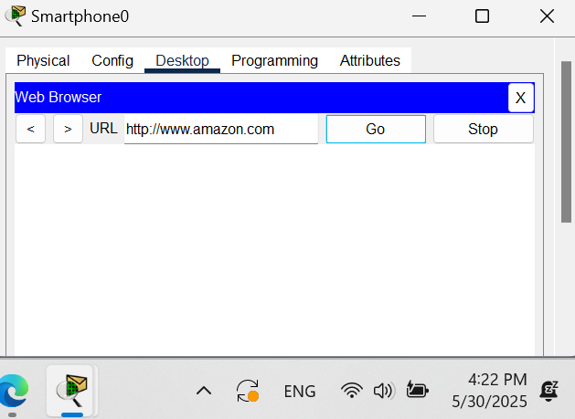

Figure 30 Web browser on the smartphone accessing [www.amazon.com](http://www.amazon.com)

## Pinging a Host in Birzeit Network from PC Amazon (Internet)

This test verifies that ICMP access is correctly denied from a lower to higher security zone by default. From PC Amazon (outside), an ICMP ping was sent to an internal host in the Birzeit network (e.g., PC with IP 172.17.26.3).

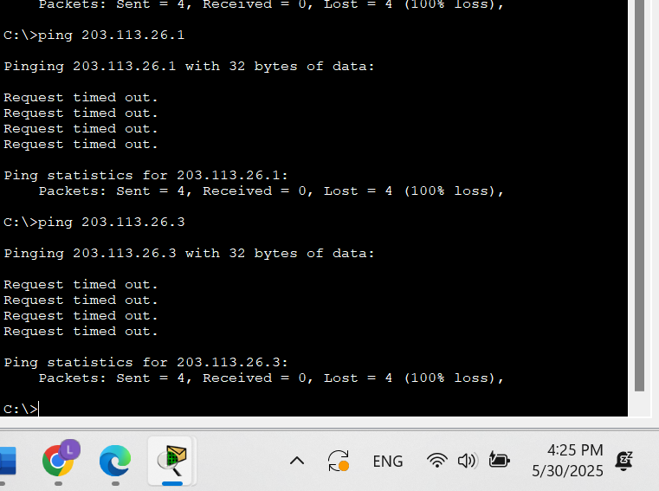

Figure 31 Failed ping from PC Amazon to internal Birzeit PC.

## Pinging PC Amazon (Internet) from a Host in Birzeit Network

This test ensures that ICMP return traffic is permitted when initiated from a higher to lower security zone. A Birzeit PC located in the Inside zone sent a ping to PC Amazon in the Outside zone.

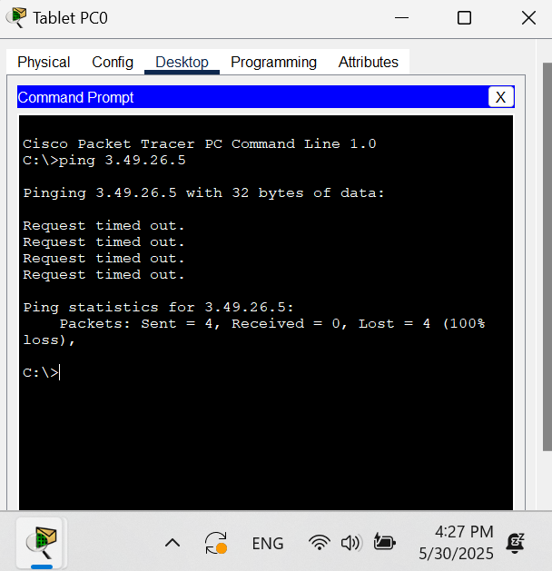

Figure 32 ping from Birzeit tablet to PC Amazon.

# Conclusion

The main objectives of configuring the ASA firewall, establishing secure network zones, implementing NAT and ACLs, and enabling secure wireless connectivity were successfully met. The expected results were achieved, with secure and controlled communication being established between the network segments. Important security principles, including the use of ACLs to manage access, the application of stateful inspection, and the integration of dynamic addressing through DHCP, were thoroughly understood and applied. The experiment reinforced the significance of firewalls in safeguarding network environments and highlighted the role of proactive security policies in protecting sensitive data and resources.

# Feedback

The experiment was found to be highly educational and provided a practical demonstration of firewall security configurations. It allowed for the application of theoretical concepts, such as ACLs and NAT, in a simulated environment. However, it was felt that the allocated lab time was somewhat limited, as additional time would have been beneficial for addressing troubleshooting issues and exploring the configurations in greater depth. Despite this, the overall learning experience was valuable and relevant to real-world security practices.

# References

**[1]** <https://computer.howstuffworks.com/firewall.htm>. [Accessed on 25th May at 3:50 PM]]

**[2]** <https://www.cisco.com/c/en/us/products/security/asa-5500-series-next-generation-firewalls/index.html>[Accessed on 25th May at 4:30 PM]]

**[3]** Lab Manual: Cisco ASA Firewall Configuration (ENCS4130).[Accessed on 25th May at 6:00 PM]

**[4]** https://www.techtarget.com/searchsecurity/definition/DMZ [Accessed on 26th May at 2:10 PM]]

**[5]** <https://www.uninets.com/blog/what-is-nat-network-address-translation> [Accessed on 26th May at 2:50 PM]

**[6]** <https://www.cisco.com/c/en/us/support/docs/ip/network-address-translation-nat/16412-pix-pat.html> [Accessed on 26th May at 3:25 M]

**[7]** <https://www.cisco.com/c/en/us/support/docs/ip/network-address-translation-nat/118659-technote-nat-00.html>. [Accessed on 26th May at 4:05 PM]]